Corvette Legends is a small club of Corvette enthusiasts who share a common bond – having fun in their Corvettes.

Corvette Legends Club activities include social events, car shows, cruise nights, color tours and trips. Proceeds from our events are donated to local charities. Corvette Legend's goal is to bring together Corvette owners to enjoy each other’s company as well as enjoy their common bond: the Corvette.

Corvette Legends has a membership of individuals from all walks of life. We have families with young children, couples, singles, and retirees that all enjoy Corvette activities whether it is a rally, dinner cruise or other programmed events. We believe that Corvette Legends has something for everyone and we do not place undue emphasis on any certain Corvette vintage.

Although Corvette Legends membership has no restrictions as to your living location, the club meetings and most of the club activities are held in Western Wayne County. Members do live outside this area and are welcomed.

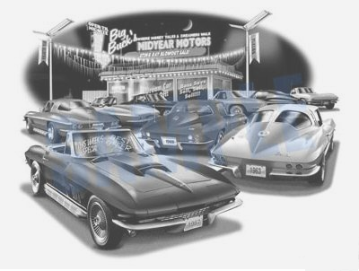
Our website provides an up-to-date listing of club events and lists other activities throughout the state that are of interest to our membership.

Check out our website
www.corvettelegends.net

CLC Activities

The following listing, although not all inclusive, indicates most of our Club Activities. See our website for all of our planned activities.

Socials Dinner cruises on the last Saturday of each month, club breakfasts as well as picnics, parades and parties.
Car Shows Many local shows and our own Corvettes at the Summit Show in July.

Cruise Nights Second Tuesday of each month May thru September at the Elks Lodge in Plymouth.
Color Tours Annual Fall Color Tour - both in Michigan and out of state.
Rallies/Trips Road rallies throughout Michigan and yearly out of state trips.

Club Meetings – October - April
Second Tuesday of each month at 6:30 PM
CJ’s Brewing Co. Beck Rd. Plymouth

Club Cruise Nights – May - September
Third Tuesday of month (Third Tuesday in July) – 6 PM
Bahama Breeze on Haggerty in Liviona

Bench Racing (Food & Conversation) - See website October - April - Second Tuesday 6 – 8 pm

Abbreviated Membership Application
Name
Spouse’s Name
Address
Home Phone#
City ____________________________State ______Zip Code
Email Address
Used for Club Communication Only
Corvette(s) Year(s) Conv _____ Coupe
Birthday (Month/Day only) You _______________Spouse
.
Applicants Signature
I can also be reached at either of the following numbers:
Day’s __________________________ Cell

Club Dues: Initiation Fee - $10.00 (one time fee)
Annual Dues (Includes Spouse) - $50.00
(Do not send any money with this application)

PLEASE NOTE
In order for us to get to know you and you to get to know us, a prospective member is required to attend three (3) Meetings or Club Sponsored Cruise Nights and three (3) Club Sponsored Events to be eligible to join the Club.
If you are interested please tear off this page & send to:
Corvette Legends Club - c/o Doug Morison 1839 Willard Dr.
Canton, MI 48187 – dhc5002@aol.com

Our website: www.corvettelegends.net
tg - 10/2014

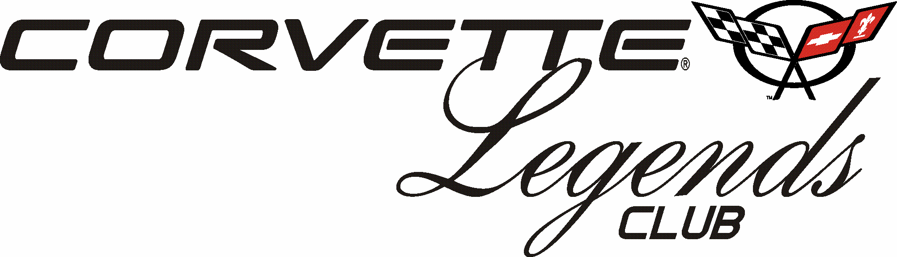

www.corvettelegends.net

Sponsored by

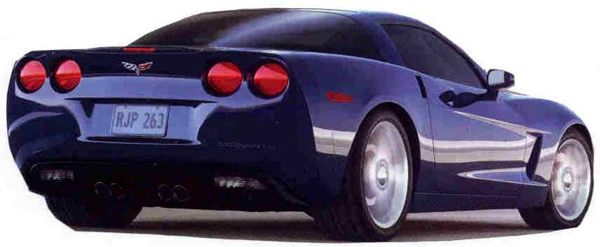

Interested in joining Our Club?
“All Corvette Owners Welcomed”

