Oil Pressure Sensor Removal and Installation Procedures

STEP1
a) The three green circles in the following picture indicate two electrical plugs and one hose that need to be disconnected
from the throttle body.
b) The red circles indicate the two screws that need to be opened up to remove the airbridge.
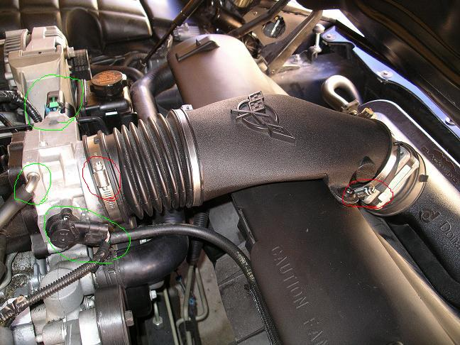

STEP2
a) The two green circles indicate a pin type rivet that can be removed by popping the top pin of the rivet with a flathead screwdriver.
This will allow the airbridge to be completely removed.
b) The red circle indicates an electrical plug that should be disconnected also.
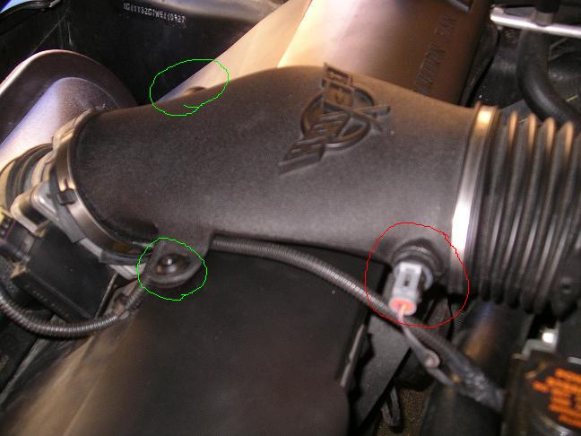

STEP3
a) Just a pic of the open throttle body, and another view of the hoses and plugs that need to be removed (green circles). Disconnect them if you haven't already.
b) The green ARROW points to the coolant hose that passes to the throttle body. This needs to be disconnected. Take a pair of pliers to the clamp on the hose that keeps it connected to the throttle body.
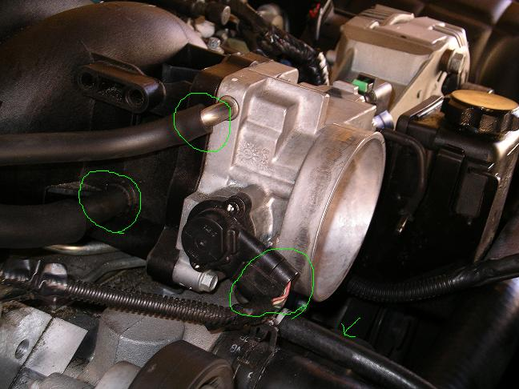

STEP4
a) Disconnect both plugs circled in green. The one on the right is easily removed by pressing down on the white ring and pulling the plug out.
b) The yellow arrow is a hose that *WAS* attached to the airbridge. Hopefully you've disconnected that from the airbridge already.
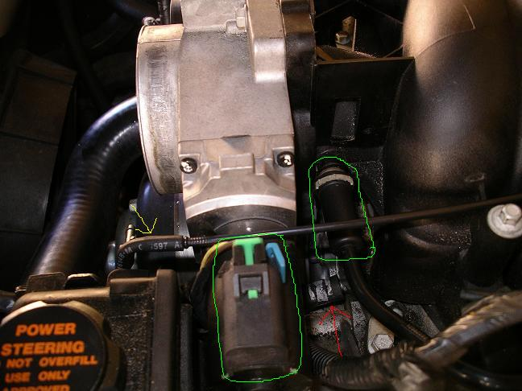

STEP5
a) Passenger side (right side) fuel injectors (red circles). Disconnect all 4 of these by pressing the metal spring and pull the injectors out.
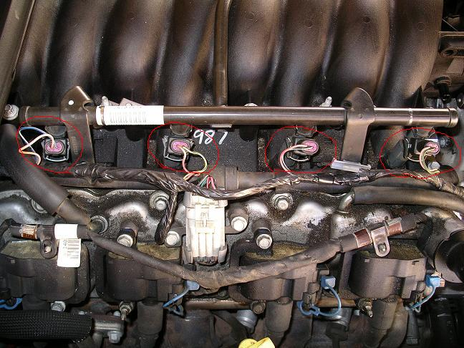

STEP6
a) Driver's side (left side) fuel injectors (red circles). As seen in the picture, all 4 need to be disconnected.
b) The items circled in green ***SHOULD NOT*** be disconnected. These are areas that I accidentally disconnected while going through blindly.
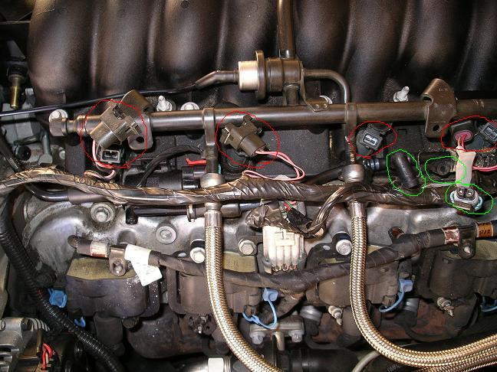

STEP7
a) The hoses circled in green are the braided fuel lines. You have to use a GM fuel line removal tool (as seen in the picture pointed by the RED ARROW).
b) This step is *NOT NECESSARY*, however, I felt it makes it easier. When the fuel lines are disconnected, you will have a small amount of fuel spill so have a rag handy to catch it.
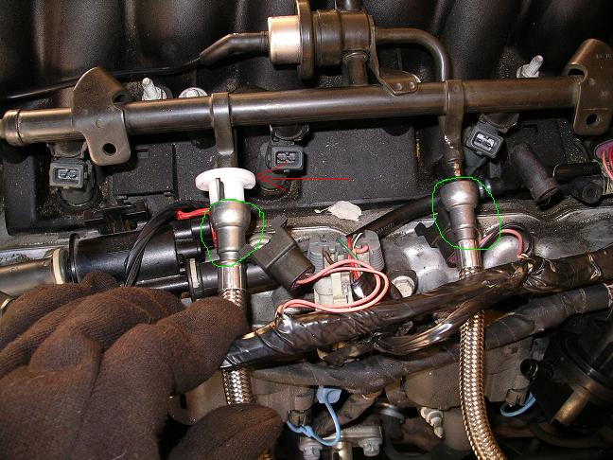

STEP8
a) This picture shows what the two fuel lines (green circles) look like with the hoses disconnected (red circles).
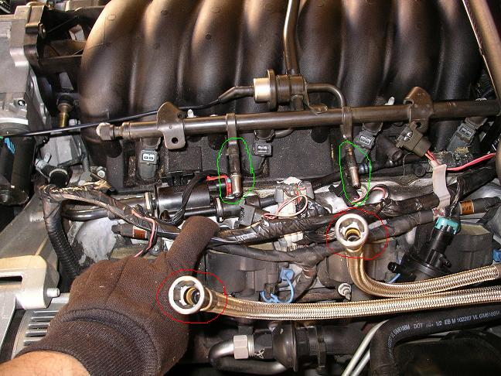

STEP9
a) The 8 circled green bolts need to be removed with an 8mm socket wrench.
b) The two green arrows point to two hidden bolts that also need to be opened up (also 8mm), but using a standard wrench instead of a socket wrench. If you use a socket wrench, it will get stuck when you've opened the bolts up. These bolts cannot be lifted out of the intake at this time. Refer to the next step.
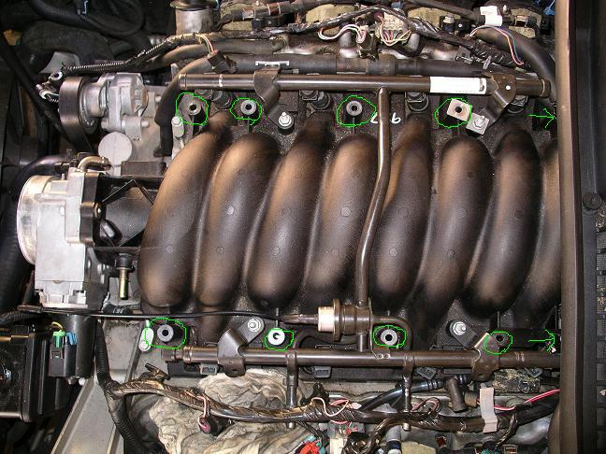

STEP10
a) The two green arrows point to those two hidden bolts. Once they've been opened up, you need to lift them up about 2 inches to give you enough clearance to pull on the intake. I used tape (as seen in the pics) to keep the bolts lifted, and free up my hands so that I could pull the intake.
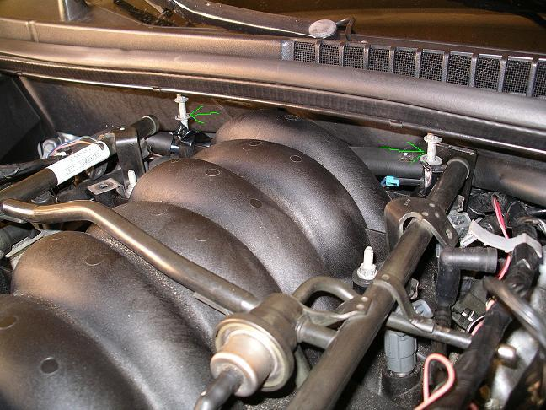

STEP11
a) With the two bolts taped (lifted clearance), you should just pull the intake up a bit and pull it towards the front of the vette. Don't pull it all the way out because there is still a hose and map sensor plugs attached in the back. The pic shows what the intake will look like once you've pulled it forward a little bit.
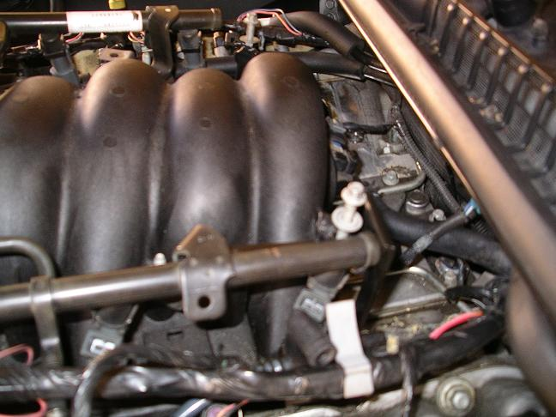

STEP12
a) This picture was taken sideways to get a better view of the hose and plug that you have to disconnect. Both are circled in green.
b) After these two things have been disconnected, you can fully take out the entire intake with the throttle body attached.
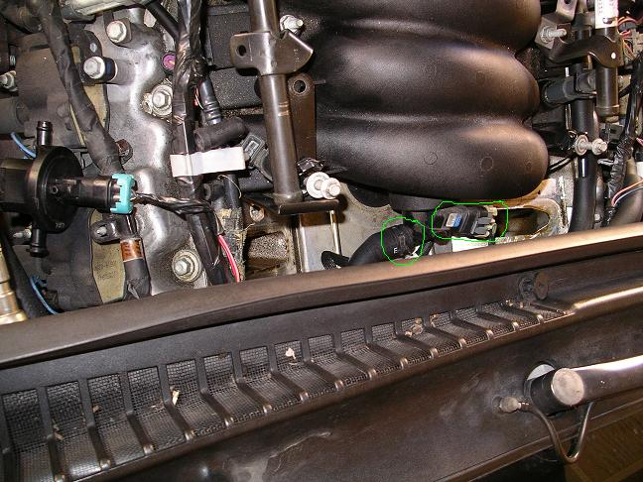

STEP13
a) Here is a pic of the engine without the intake & throttle body. And opening the clearance to what you've been waiting for. The Oil Pressure Sensor is indicated by the green circle in the picture. I don't remember which socket size to use but it needs to be a deep socket. Pretty simple removal and installation, as it isn't in there extremely tight, you'll have plenty of clearance to put a socket wrench and deep socket in there. Just make sure you remove the electrical plug connector that goes to the Oil Pressure Sensor, before you try to remove it. Install the new one, and plug the electrical connector back in.
b) The item circled in red looks like a plastic straw. Just pay attention to this when you re-install the intake, there is a hose that it needs to reconnect to (hose is shown in the STEP14 picture).
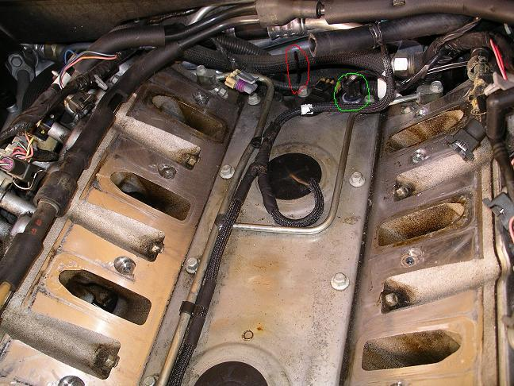

STEP14
a) Here is a picture of the removed intake, and the hose mentioned in STEP13b is circled in green. When you re-install the intake, just make sure the red plastic stick (in red circle of picture on STEP13) is fitted back into this hose.
b) From here, after you've installed the new Oil Pressure Sensor, the re-installation of the intake manifold should be exactly in reverse order.
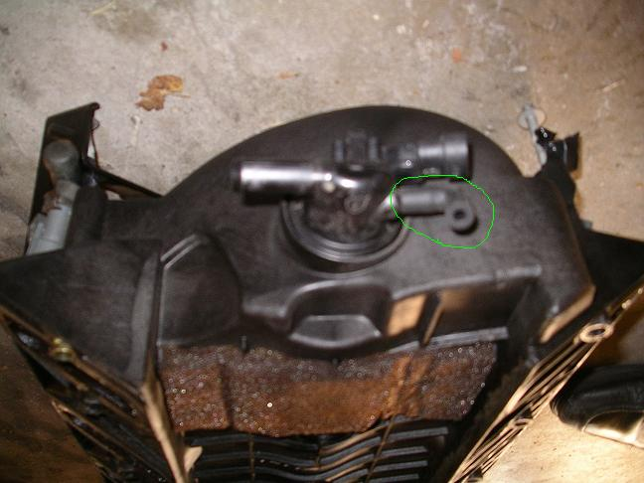

INSTALLATION COMPLETE
Tools:
8 mm socket for 3/8" drive, 10 mm deep socket, hose clamp tool, fuel line tools, oil pressure sender socket (1-1/16" deep socket

Torque values:
oil pressure sender: 15 ft-lbs
intake bolts: 44 in-lbs first pass, 89 in-lbs second pass

The hose clamp tool isn't really required, but it makes that back hose really easy to disconnect, and is a godsend for other tough to reach clamps. I think I got mine from Harbor Freight, and could NOT find it at Autozone or Kragen....but I lost mine during my move a couple weeks ago, so instead of disconnecting the hose from the end at the rear of the intake, I disconnected the end at the brake booster and removed the entire hose...much easier!

As you stated, removing the fuel lines isn't necessary, but if done, the right tools are needed to complete that task as well.

I have a Vararam with smooth air bridge to throttle body coupler, and I find it easier to unbolt the throttle body and remove everything from the throttle body to the top of the Vararam as one unit. Good time to clean the filter too!

