rticles

1963-1967 Corvette Headlamp Motor Replacement
0
Posted September 12, 2012 by Zip Corvette in Corvette Technical Articles

Nothing is more aggravating to a 1963 to 1967 Corvette owner than to turn on the headlight motor switch and have only one headlight open. How about turning on the switch and the headlights open so slowly that it will be daylight before they are fully open? These are very common problems. Headlamp motors wear out with use. Pivot bearings freeze up and pilot shafts wear out. These and all the other problems associated with these headlamp assemblies can be cured with a call to Zip Corvette Parts, 8067 Fast Lane, Mechanicsville, VA 23111, (800) 962-9632. They have a complete line of repair parts for these 1963 to 1967 headlight assemblies. Our project 64 had one headlight that did not operate at all and the other was very slow. We called Zip and secured all of the parts we needed to re-do the whole system. The repair process was not very hard and we completed the job in about 4 hours. Follow along as our project 64 goes from being a one-eyed wonder to being able to see in the dark.
Click on the images for expanded views – it’s much easier on the eyes.
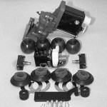
Step 1
01: These are the Corvette parts Zip supplied for our headlight repair: Headlamp Motor, Headlight Mounting Kit, Pivot Balls, Felt Washers and Seals, Warning Light Switches, Headlight Switch and Limit Screws. You will also need some hand tools and a shop manual for your year Corvette. These manuals are also available from Zip Corvette Parts.
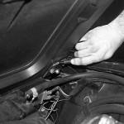
Step 2
02: Start by removing the hood. Use a grease pencil to outline mark the hood hinge locations. This way you will be able to replace the hood in the exact same location.
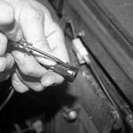
Step 3
03: Disconnect the battery and then disconnect the motor lead wire from the motor. It has a locking tab on it that you will have to release so it can be removed. A small screwdriver will help to release the tab.
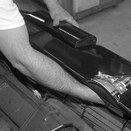
Step 4
04: Turn the knurled knob on the inboard side of the motor until the gear seems to turn freely. Now turn the knob in one direction until a definite drag is felt. Then rotate the knob approximately six complete turns in one direction. NOTE: Use your free hand to help move the headlamp assembly as you turn the knob to produce a no-load condition on the drive gear and to permit separation of the motor from the panel pivot shaft.
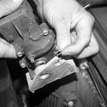
Step 5
05: The retainer can now be removed from the motor locating stud. Now remove the motor to support retaining screw and remove the motor assembly.
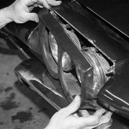
Step 6
06: Make sure the headlamp is in the open position and remove the headlight bezel.
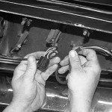
Step 7
07: Remove the sealed beams and headlight housing assembly as one unit. Disconnect the sealed beam units at the harness connector.
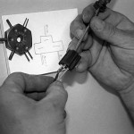
Step 8
08: Make a diagram of how the headlight housing wiring connects to the harness. To remove the wiring stud connections, use a small screwdriver or spade removal tool to release the retaining prongs in the connector.
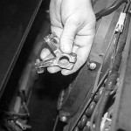
Step 9
09: Now remove the panel stop from the inboard pivot shaft.
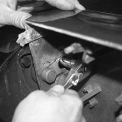
Step 10
10: The panel retaining bolt access hole plugs will have to be removed now. With these removed, rotate the panel as required and remove the retaining bolts and slide the supports from the end of the shafts. Remove the bearings, felt seal, retainer and washer from the inboard pivot shaft.
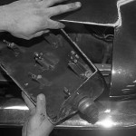
Step 11
11: The headlight panel can be removed by disengaging the pivots from their retaining slots and sliding the unit forward through the opening in the body. This is the hardest part. Be careful. You do not want to scratch the headlight panel while working it out of the body.
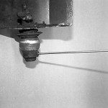
Step 12
12: Loosen the allen screw in the spacer and disassemble the outboard pivot shaft.
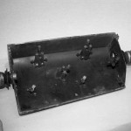
Step 13
13: For reference, here is what the entire assembly looks like when it is installed.
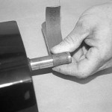
Step 14
14: Before you start the re-assembly, take a piece of emery cloth or 600 grit sandpaper and clean up the pivot shaft. Now install the washer, retainer, felt seal, bearing and spacer in that order to the outboard pivot shaft. Do not tighten the spacer on the shaft yet, only snug the allen set screw.
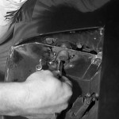
Step 15
15: Place the panel in the body opening and index the panel pivot shafts in the retaining slots. Now loosely install the support retaining bolts.
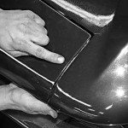
Step 16
16: Now install the washer, retainer, felt seal, bearing and support in that order to the inboard pivot shaft and loosely install the support retaining bolts. Check the side to side alignment. Make sure that there is no body to panel contact. Place the spacer snugly against the bearing and tighten the spacer set screw. Make it snug 30-50 inch pounds.
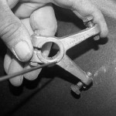
Step 17
17: The Y-Stop should be installed on the inboard pivot shaft so that it rests against the bearing. Be sure the index mark on the stop is aligned with the flat on the pivot shaft. Install the Y-Stop lock bolt and torque to 45-60 inch pounds. Re-check your side to side panel movement and make sure it has not changed.
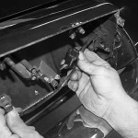
Step 18
18: Check and align the panel to the body as follows:
a. Tighten the panel pivot support bolts snugly while still allowing the panel to be moved by applying hand pressure.
b. Position the panel in the closed position and align with the body so that all surfaces are flush.
c. With the panel in the closed position the outboard access hole is aligned with the forward bolt head. Tighten this bolt with the panel in the closed position. The access to the bolt head can be obtained by working through the opening between the body and the radiator core support.
d. Rotate the headlight panel to obtain access to each bolt head and torque the bolts to 100-140 inch pounds.
Install the sealed beam housing unit and at the same time position the sealed beam lead wires through the panel outboard pivot shaft. Install the housing unit retaining screws and install the lead wires in the connector making sure to match the colors between the harness and the connector. Refer back to your diagram to make sure that you are connecting the wires to the right terminals.
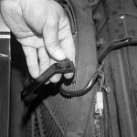
Step 19
19: Now install the headlamp motor mounting bracket assembly.
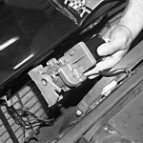
Step 20
20: Rotate the motor and the headlamp panel as required to align the slot in the motor with the headlamp panel pivot shaft and install the motor on the shaft so that the bracket is aligned with the locating stud. NOTE: It may be necessary to turn the knurled knob on the end of the motor to permit alignment of the motor with the shaft. Slide the motor onto the shaft until it seats against the shaft shoulder; then install the retainer in the groove on the locating stud. Now install the motor-to-support retaining screw making sure the ground wire is installed between the screw head and the bracket. Connect the motor lead wires, making sure that the contacts are clean and that the connection is secure. With all of this done, you can now re-install the hood and re-connect the battery.
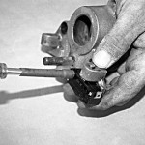
Step 21
21: It is also a good idea to replace the headlight warning switches. We did this out of the car so you could see how it installs on the pivot support.
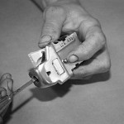
Step 22
22: We also replaced our 30 year old headlight switch. To remove the knob and shaft, push in the spring loaded button and pull the knob and shaft out of the switch assembly. With the knob and shaft removed, unscrew the center retaining bezel and the switch can then be removed from the back of the dash. Disconnect the wiring. Install the new switch and reverse the procedure. NOTE: If you are going to install a new headlight switch, I would recommend disconnecting the battery while you remove and replace the switch.
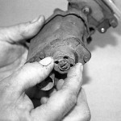
Step 23
23: Here is a close-up view of the knurled knob on the headlight motor. This will allow you to open the headlamps manually, if need be.
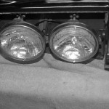
Step 24
24: If you want to keep the headlamp panel from getting scratched while you are working on it, place a towel on the bumper.
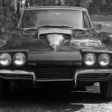
Step 25
25: This is our Project 64 all re-assembled and no longer a one-eyed Jack.
1963-1967 Corvette Headlamp Motor Replacement: Headlamp Motor Assembly Rebuild
Source:
By: Greg Donahue

