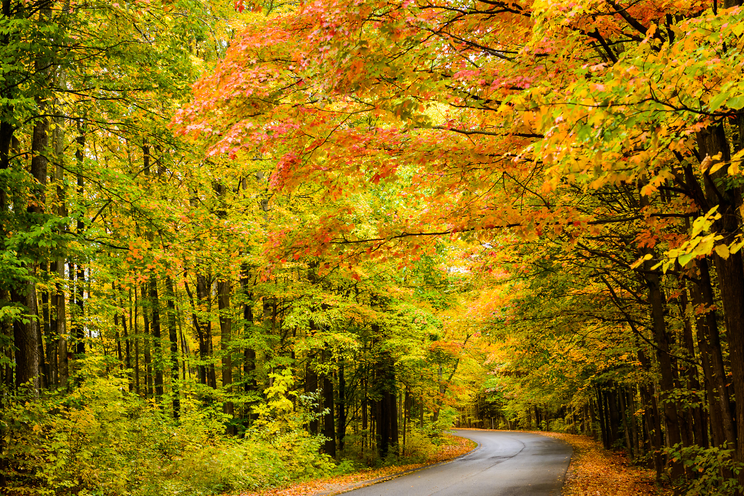
Welcome to the
Corvette Legends Fall Color Tour for 2017.
Friday, October 13th thru Sunday October 15th.

The Lodging locations are listed below.
We have reserved a book of 20 rooms at each
of the two Best Western Hotels (Ludington and Grand Haven).
Please phone in your reservation to each hotel as soon as possible
before 9/15/17.

A Brief Itinerary of the Fall Color Tour
This will be a three-day event driving through some of the most beautiful areas
of our Great State of Michigan.
On Friday morning we will be meeting at the Fowlerville Farms Restaurant,
located at the Fowlerville exit from I-96 just West of Howell.
After eating breakfast we will work our way West and North on paved surface roads
and eventually begin our encounter with the Huron-Manistee National Forest.
This forest covers a very large portion of the Western Half of Michigan.
After stopping for lunch in Newaygo we will proceed North along M37
until we will have traversed the National Forest.
Then we will head West to the shores of Lake Michigan
and begin our Southerly drive along the shoreline
passing through Manistee and arriving for our first nights stay at Ludington.

Saturday morning, our second day, we will once again seek out the Lake Michigan Shoreline
and view some of the most beautiful sights that we will see this weekend.
Later that day we will arrive in time for lunch in Grand Haven and for our second nights stay.
After Lunch, most of us will, no doubt, wish to continue on to Saugatuck
for an afternoon of shopping in this quaint little tourist town.
If this town has not been on your bucket list,
you will know why most Michiganders have had it on theirs for some time.
The downtown shopping area is made up of 3-4 parallel streets filled with unusual little shops
with virtually anything you can imagine to purchase.
Or you can walk along the marina’s coastline looking at the many boats and swimmers (in October, maybe not)
Some of the most powerful boats on the Great Lakes often dock here.
It’s a favorite spot for Chicago’s elite.

On Sunday morning we begin our trek home
possibly stopping for lunch at a colorful spot along the way.
The location is yet to be determined.
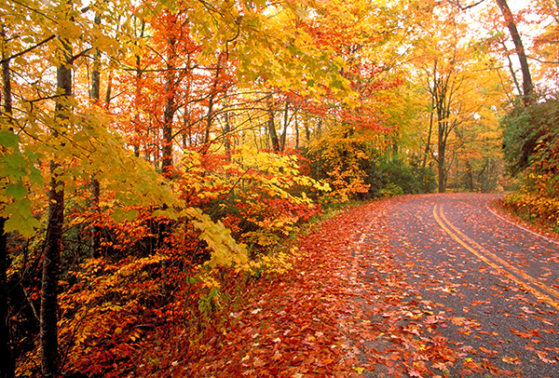
Overnight Accommodations
Friday October 13, 2017
Ludington - Best Western Lakewinds
- 2 Queen Beds $111 (20 rooms in the name of Corvette Legends)
5005 W US Highway 10, Ludington, MI (231) 843-2140

Saturday October 14, 2017
Grand Haven - Best Western Beacon Inn

2 Queen Beds

$ 108 main hotel (10 rooms in the name of Corvette Legends)

$ 90 attached 2 story motel (no elevator) – park near your room (10 rooms in the name of Corvette Legends)
1525 S Beacon Boulevard, Grand Haven, Michigan 49417 (616) 842-4720

