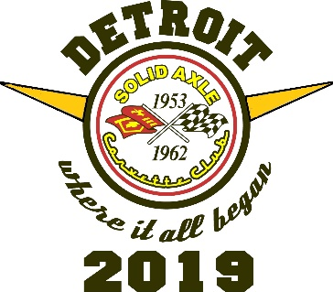 | 2019 SACC National Convention  - Metro Detroit, Michigan Area - August 13-16, 2019  Activity Highlights  Hosted by Michigan Chapter SACC | 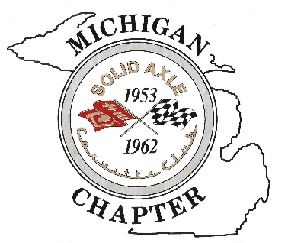
Lingenfelter Collection - Enjoy this impressive private collection of more than 150 unique cars in a 40,000 square foot space. Lunch will be provided on site. This collection is not open to the public.
Pratt & Miller – Pratt & Miller technology, products, and personnel have propelled Corvette Racing to the pinnacle of production-based sports car competition. Since 1999, Corvette Racing has won over 100 races worldwide and the team has won the 24 Hours of Le Mans, the world's biggest sports car race, an unprecedented eight times since 2001. The racing spirit is the power that drives Pratt & Miller Engineering – a world-class engineering powerhouse with a global footprint.
GM Heritage Center – This 81,000 square foot center showcases vehicles of the GM Heritage Collection, along with other artifacts on display. The vehicle displays frequently change and generally has more than 165 vehicles on display at a time. Each of these vehicles illustrates a design, technical or sales milestone or accomplishment in the history of General Motors or the automotive industry. We will have GM representatives on site to talk with and ask questions. This venue is not open to the public.
GM Renaissance Center (RenCen) – this landmark is the world headquarters of the General Motors Company. Be sure to check out the GM World vehicle display, the “Borealis” - the tallest vertical art glass sculpture in the world located in the North Lobby, the outdoor GM Plaza with a world map carved in granite and see the synchronized water fountain. Be sure to visit the shops in the GM Wintergarden, RenCen, and especially the GM Company Store to purchase GM collectibles. Walking east along the Detroit River, you’ll be heading toward Rivard Plaza where the Cullen Family Carousel is located.
Diamond Jack River Tour – board the vessel for our chartered leisurely two-hour evening cruise with narration, presenting highlights of the Detroit and Windsor, Ontario, Canada skylines, along with historical anecdotes about both cities. Hopefully, we’ll pass by a Great Lakes freighter along the way. Restrooms & snack bar available on board. (CAPACITY LIMITED FOR THIS RIVER TOUR.)
THE FOLLOWING EVENTS ARE NOT PRE-PAID. For the first three, please see: https://www.thehenryford.org/visit/plan-your-visit
The Henry Ford - provides unique educational experiences based on authentic objects. Stories and lives from America’s traditions of ingenuity, resourcefulness, and innovation. Step into a world where past innovations fuel the imagination of generations to come. A vibrant exploration of genius in all its forms, Henry Ford Museum allows you to experience the strides of America’s greatest minds while fully immersing yourself in their stories. Step inside the bus where Rosa Parks took a stand by taking a seat. Play pilot as you explore flight innovations, starting with the Wright brothers’ achievements, or make yourself at home inside Buckminster Fuller’s circular Dymaxion House. Put yourself in the place of movers and shakers who blazed the trail to where we stand today.
Greenfield Village - experience a place where over 80 acres brim with resourcefulness and ingenuity. Where 300 years of American stories pulse with life. Step foot in the lab where Thomas Edison had his lightbulb moment. The Bagley Avenue shed recreated by Henry ford to share the story of where he built his first car. Or the workshop where the Wright brothers taught us to reach for the sky. Discover our nation’s most formative years - at the place where everything feels astonishingly real. Because it is.
Ford Rouge Factory Tour - Pop open the hood on game-changing technology, sustainable design and sheer American grit at America’s greatest manufacturing experience. Get an inside look at the making of America’s most iconic truck, the Ford F-150, and immerse yourself in modern manufacturing’s most progressive concepts. Experience the awe–inspiring scale of a real factory floor as you rev up your inner engineer. This is where big ideas gain momentum.
Automotive Hall of Fame – Founded in 1939 and has over 800 worldwide inductees, including persons who have contributed greatly to automotive history. Located across the parking lot from the Henry Ford, admission tickets available for purchase at the Hall.
Woodward Dream Cruise (This event is optional & arrangements can be made with Michigan NCRS) - The Woodward Dream Cruise is the world’s largest one-day automotive event, drawing 1.5 million people and 40,000 classic cars each year from around the globe—from as far away as New Zealand, Australia and Japan, to name a few. North American cruisers from California, Georgia, Canada and all points in between caravan to Metro Detroit to participate in what has become, for many, an annual rite of summer.

