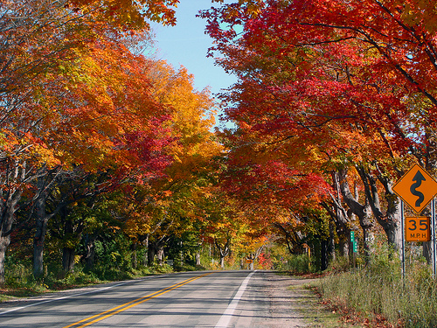

Saturday
October 12, 2019

Five Mile Rd at Sheldon
(Near Fresh Thyme Farmers Market)
Arrival Time–9:00 am (for breakfast)
Departure Time–10:00 am
Tour Western Michigan
We will be stopping for a snack along the way. We also plan to stop for dinner at the end of the day’s travel at Zukey Lake Tavern in Pinckney.
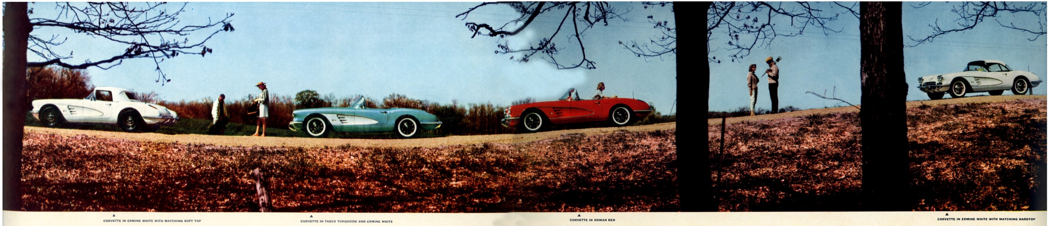

A little bit of Driving
A little bit of Eating
A little bit of Shopping
A little more Eating

Contact Paul & Anita - Let us know if you are participating
Call (734)737=0089 or email pjenkins327@att.net

