February Lunch Cruise
Saturday, February 1, 2020 at 12 Noon
50/50 Raffle with prizes too.
All proceeds go to Camp Able
Logan’s Roadhouse
Ford Road just East of Lotz Road
(In front of Home Depot)
Saturday, February 1st at 12 Noon
Good Food & Drinks
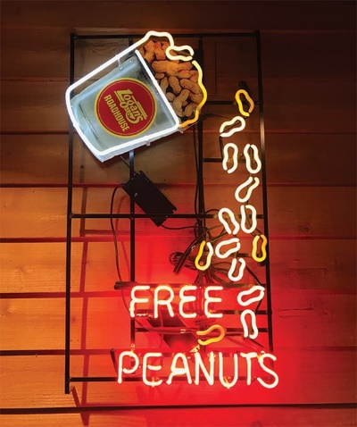
Please contact Paul Jenkins
with your RSVP
(734)737-0089 or pjenkins327@att.net

Please respond not later than Wednesday, January 29th

